**Swipe Down to Refresh List View Using Refresh Control**

Here is an example of React Native Swipe Down to Refresh ListView Using Refresh Control. It was first introduced in Android Material Design and became very popular. Almost all Apps are using Swipe down to refresh. In React Native you can use this feature using RefreshControl provided by React Native.

To Import Refresh Control in Code

**import** { RefreshControl} **from** 'react-native'

Swipe Down to Refresh ListView Using Refresh Control

<FlatList

data={this.state.dataSource}

ItemSeparatorComponent={this.ListViewItemSeparator}

enableEmptySections={true}

keyExtractor={(item, index) => index.toString()}

renderItem={({item}) => (

<Text

style={styles.rowViewContainer}

onPress={() => alert(item.id)}>

{item.title}

</Text>

)}

refreshControl={

<RefreshControl

//refresh control used for the Pull to Refresh

refreshing={this.state.refreshing}

onRefresh={this.onRefresh.bind(this)}

/>

}

/>

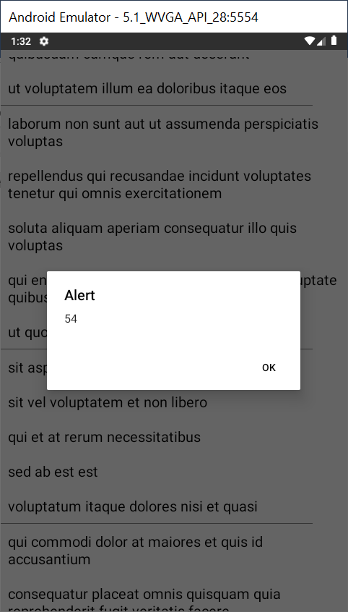

//This is an example code for React Native Swipe Down  to Refresh ListView Using RefreshControl//

import React, { Component } from 'react';

//import react in our code.

import {

  StyleSheet,

  ActivityIndicator,

  FlatList,

  Text,

  View,

  Alert,

  RefreshControl,

} from 'react-native';

//import all the components we are going to use.

export default class Project extends Component {

  constructor(props) {

    super(props);

    //True to show the loader

    this.state = { refreshing: true };

    //Running the getData Service for the first time

    this.GetData();

  }

  //Service to get the data from the server to render

  GetData = () => {

    return fetch('https://jsonplaceholder.typicode.com/posts')

      .then(response => response.json())

      .then(responseJson => {

        this.setState({

          refreshing: false,

          //Setting the data source for the list to render

          dataSource: responseJson

        });

      })

      .catch(error => {

        console.error(error);

      });

  };

  ListViewItemSeparator = () => {

    return (

      //returning the listview item saparator view

      <View

        style={{

          height: 0.2,

          width: '90%',

          backgroundColor: '#808080',

        }}

      />

    );

  };

  onRefresh() {

    //Clear old data of the list

    this.setState({ dataSource: [] });

    //Call the Service to get the latest data

    this.GetData();

  }

  render() {

    if (this.state.refreshing) {

      return (

        //loading view while data is loading

        <View style={{ flex: 1, paddingTop: 20 }}>

          <ActivityIndicator />

        </View>

      );

    }

    return (

      //Returning the ListView

      <View style={styles.MainContainer}>

        <FlatList

          data={this.state.dataSource}

          //Used to extract a unique key for a given item at the specified index.

          //Key is used for caching and as the react key to track item re-ordering.

          keyExtractor={(index) => index.toString()}

          ItemSeparatorComponent={this.ListViewItemSeparator}

          //Flag indicating whether empty section headers should be rendered

          enableEmptySections={true}

          renderItem={({ item }) => (

            <Text

              style={styles.rowViewContainer}

              onPress={() => alert(item.id)}>

              {item.title}

            </Text>

          )}

          refreshControl={

            <RefreshControl

              //refresh control used for the Pull to Refresh

              refreshing={this.state.refreshing}

              onRefresh={this.onRefresh.bind(this)}

            />

          }

        />

      </View>

    );

  }

}

const styles = StyleSheet.create({

  MainContainer: {

    justifyContent: 'center',

    flex: 1,

    marginTop: 10,

  },

  rowViewContainer: {

    fontSize: 20,

    padding: 10,

  },

});